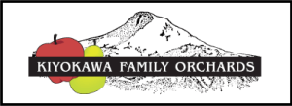
Price list effective until November 30, 2023

APPLES (20-22 lbs. per box)
*Jonagold $23.25
*Red Ruben $23.25
*Gala $23.25
*Ambrosia $23.25
*Fuji $23.25
*Honeycrisp $32.25
*Crimson Crisp $32.25
*Mountain Rose $32.25
*Newtown Pippen $23.25
*Cameo $23.25
*Mixed Premium Apples $27.50
(boxes contain 4 to 5 of the following varieties: Fuji, Gala, Crimson Crisp, Newtown, Red Ruben, Jonagold, Cameo, Ambrosia)

PEARS (22-25 lbs. per box)
*D’Anjou $23.25
* Bartlett $23.25
*Premium Mixed Winter Pears $27.50
(boxes contain 4 to 5 of the following varieties: Red & Green D’Anjou, Comice, Bosc, Warren, Taylor’s Gold)
*Mixed Asian Pears *LIMITED QUANTITIES* WHILE SUPPLIES LAST* $33.00

